EM5910
Intelligent Digital Multimeter

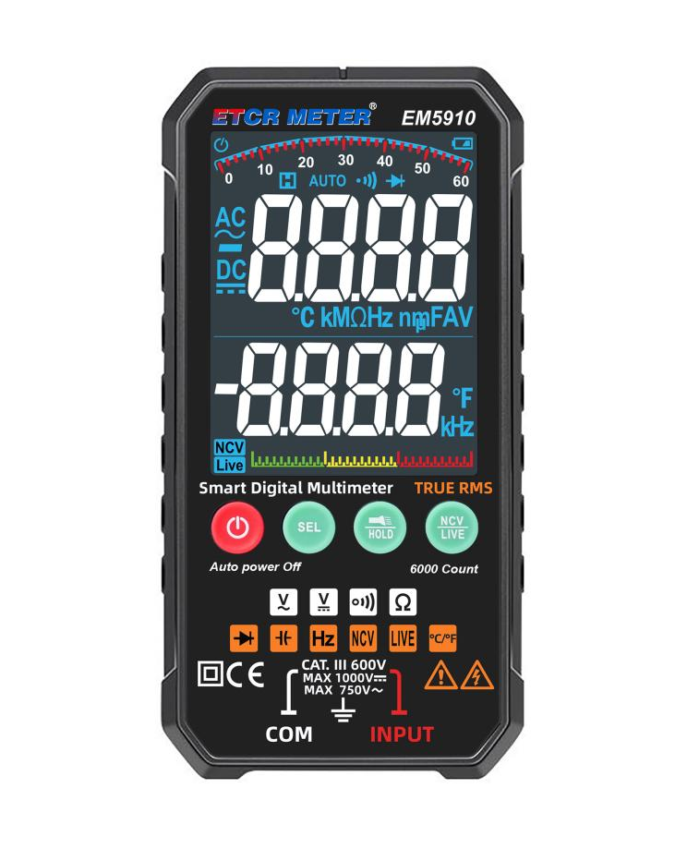
Product Function
- Measurement of AC voltage true effective value (TRMS), DC voltage, resistance, frequency, capacitance, temperature, continuity test, NCV, diode , etc.

- The portable 6000-count automatic range digital multimeter is compact in structure, easy to operate and convenient to carry. It is an ideal tool for electrical and electronic measurements.
- Equipped with large LCD display, which is convenient for the user to read the measured value in dark place.
- With automatic shutdown, data hold and a lighting lamp function.

Product Features

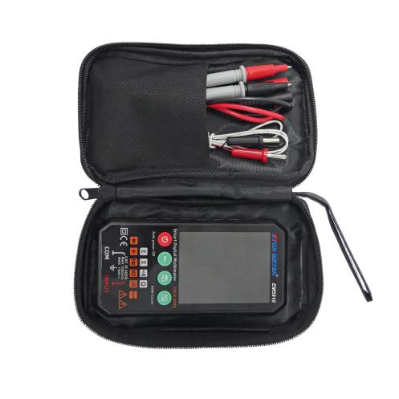
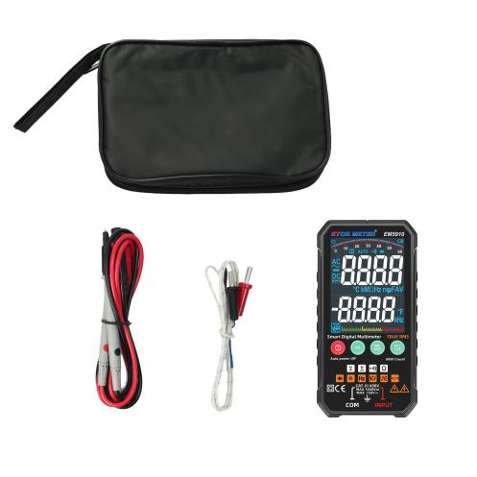


Technical Specification

Power Supply | DC3V Alkaline dry battery (LR03 1.5V x 2PCS)
LCD Size | 52mm x 67mm; Max display: 5999
Voltage Measurement | Range: DC 6V, 60V, 600V, 1000V | ± (0.8 % + 3)
Voltage Measurement | Range: AC 6V, 60V, 600V, 750V | ± (1.0 % + 3)
Resistance Measurement | Range: 600Ω, 6kΩ, 60kΩ, 600kΩ, 6MΩ, 60MΩ | ± (1.2 % + 3)
Capacitance Measurement | Range: 6nF, 60nF, 600nF, 6uF, 60uF, 600uF, 6mF | ± (3 % + 5)
Frequency Measurement | Range: 6Hz, 60Hz, 600Hz, 6kHz, 60kHz, 600kHz, 6Mhz | ± (0.1 % + 3)
Thermometry | Range: 0℃ ~ 1000℃ | ± (5.0 % + 4)
NCV Function | Yes
Backlight | Yes
Data Hold | Yes
Continuity Measurement | Yes
Diode Measurement | Yes
Automatic Shutdown | Automatic shutdown after starting up 14 minutes without any operation
Overflow Display | Over range overflow function: the highest digit display “OL”
Overload Protection | Yes
Input Impedance | 10MΩ
Battery Voltage |   When battery power indicate “ ”symbol, remind to replace the battery
Working Temperature | 0℃ - 40℃ RH < 75 %
Store Temperature | - 10℃ - 60℃ RH < 80 %
Meter Weight | Approx. 146g (include accessories)
Meter Dimension | 142mm x 70mm x 20mm
Accessories | Meter*1PC;  Probe*1SET  Temperature probe*1PC;  Tool bag*1PC;  LR03 battery*2PCS

